Open width washing machine ARIOLI 2286
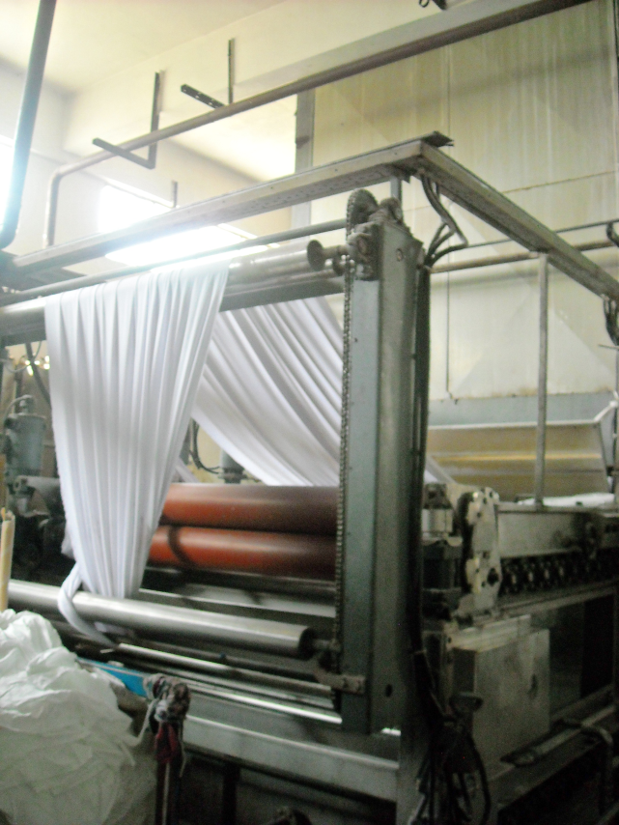

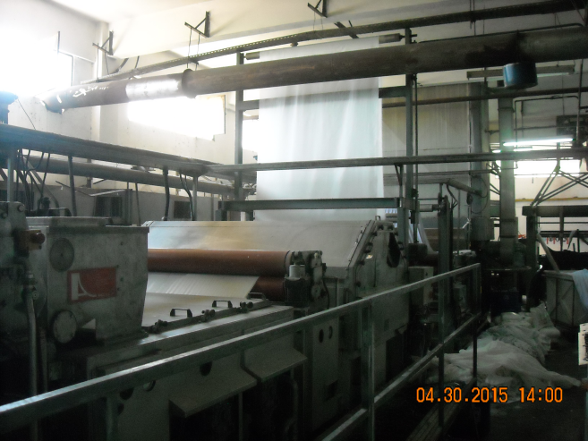
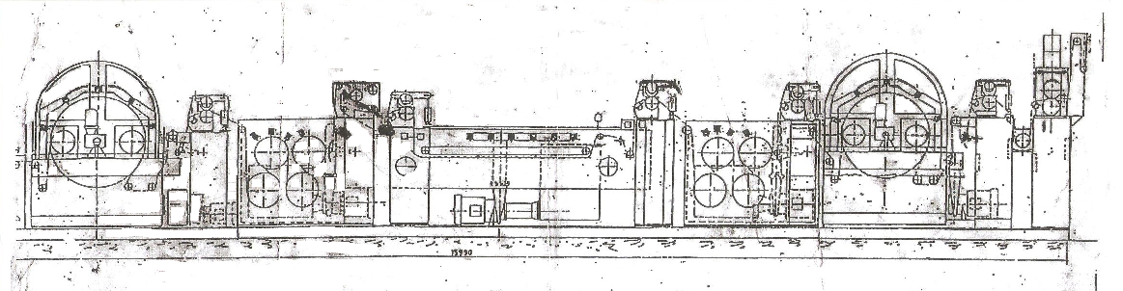
Open width washing machine ARIOLI 2286 ww 220 yoc 1988
5 compartiments with squeezers + Impregnation padder column steamer
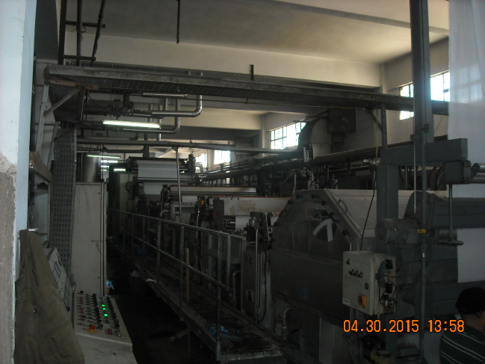
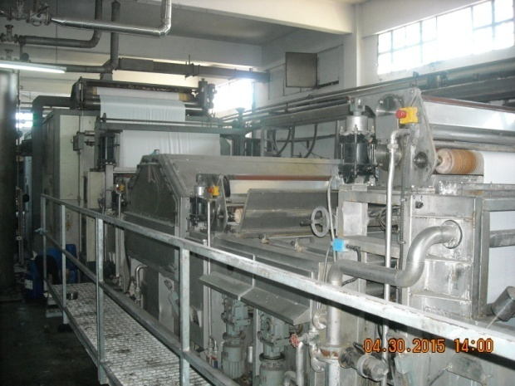

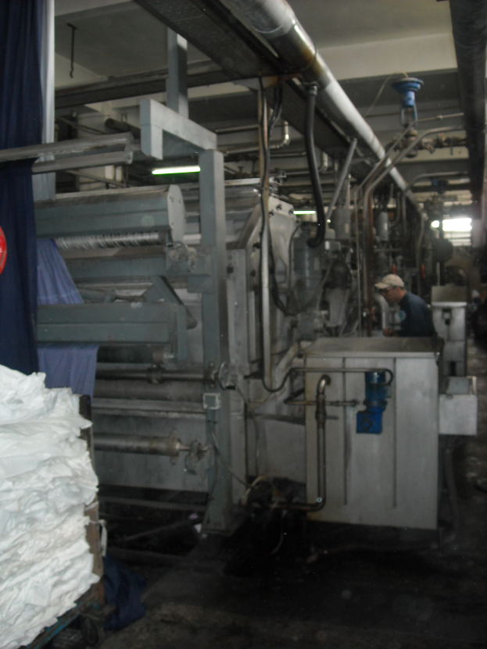

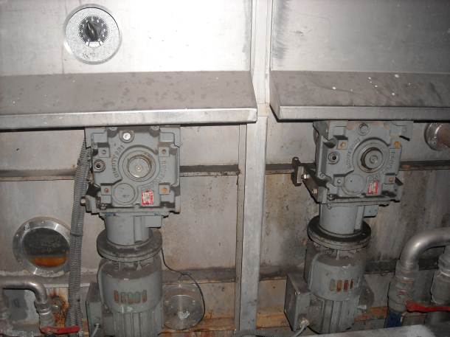
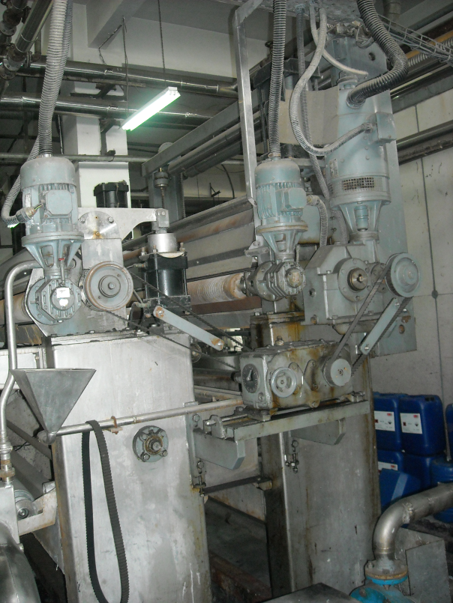
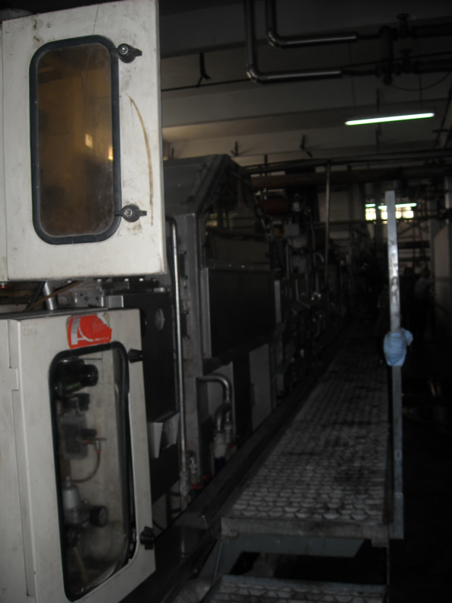

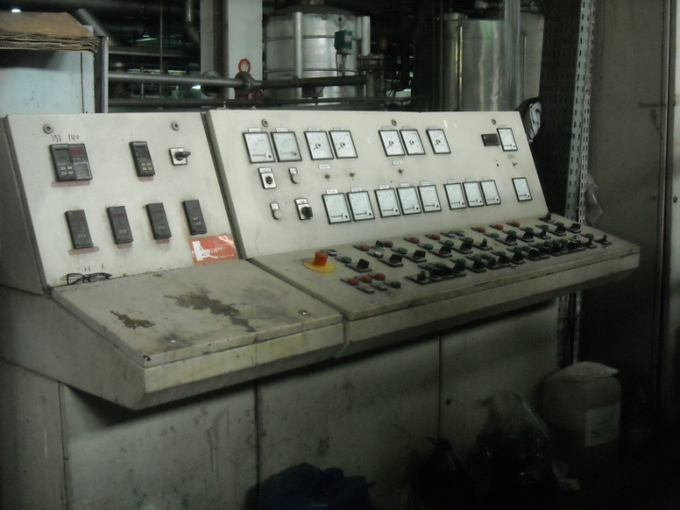
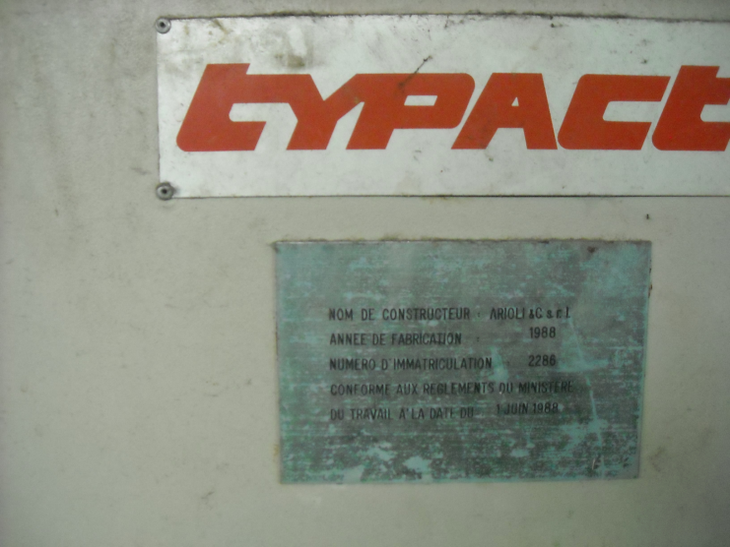

ARIOLI CONTINUOUS WASHING LINE AFTER PRINTING FOR FABRICS WITH 5 TANKS, WORKING WIDTH 2000MM, YEAR 1986
- HIGH ENTRANCE WITH TENSION BARS AND KUSTERS GUIDER AND SPREADERS
- 1ST TANK WITH 1 PERFORATED DRUM, DIAMETER 1.200 MM
- INTERMEDIATE SQUEEZER WITH 2 BOWLS
- 2ND TANK WITH 4 PERFORATED DRUMS, DIAMETER 450 MM
- INTERMEDIATE SQUEEZER WITH 2 BOWLS
- 3RD TANK FOR THE FABRIC RELAXING, WITH DOUBLE CONVEYOR IN STAINLESS STEEL (THE FABRIC RUNS IN BETWEEN THE TWO CONVEYORS)
- INTERMEDIATE SQUEEZER WITH 2 BOWLS
- 4TH TANK WITH 4 PERFORATED DRUMS, DIAMETER 450 MM.
- INTERMEDIATE SQUEEZER WITH 2 BOWLS
- 5TH TANK WITH 1 PERFORATED DRUM, DIAMETER 1.200 MM.
- INTERMEDIATE SQUEEZER WITH 2 BOWLS
- HEAVY SQUEEZER WITH 2 BOWLS, WITH IMPREGNATION TANK
- EXIT BY PLATER
- THE TANKS ARE EQUIPPED WITH SELF-CLEANING FILTER
- ELECTRIC CONTROL BOARD AND CONTROL CONSOLE
- DIMENSIONS OF THE LINE : LENGTH ABOUT 16.000 MM. – WIDTH ABOUT 4.500 MM
THE MACHINES HAVE NO PLATES, BUT WE HAVE FOUND THE CONSTRUCTION YEAR ON THE ELECTRIC DRAWINGS

